**Learning about urban mitigation solutions**

William F. Lamb, Felix Creutzig, Jan C. Minx, Max C. Callaghan

**It is often remarked that cities could lead the way in climate change mitigation and provide a test-bed for policy experiments and social change. In this regard there is already a large body of case study literature to learn from and translate into different urban contexts** 1**. However, a number of practical and conceptual challenges stand in the way. First, the literature tends to focus on cases in large, wealthy and globally connected cities, despite the majority of the global population residing in much smaller agglomerations. Second, a comprehensive overview of which mitigation topics have been researched for what cities is currently lacking. Third, secondary analysis of the case study literature is extremely sparse and does not employ structured methods. Learning about urban mitigation solutions requires (…)**

Cities experience similar dynamics of urbanisation and agglomeration 2, are faced with structurally comparable decarbonisation challenges 3, and are increasingly interconnected through trade, globalisation, and coordinated social or political movements 4,5. The opportunities for comparative research across cities are therefore widely discussed 6,7, with much of the urban climate change mitigation literature dedicated to case studies of local mitigation actions, or horizontal comparisons of actions across a small number of cities. Learning from these studies is important to satisfy increasing demands for a solutions orientation in the field 8 and to support the urgent upscaling of efforts required to keep global warming below 1.5°C or 2°C 9.

The 6th Assessment Cycle will again include dedicated chapters on urban systems, in both Working Groups II and III. Urban assessments and research networks are in their infancy, but gaining momentum (UCCRN, ICLEI). Case studies are prominent in these assessments: often they are presented in dedicated boxed sections (IPCC, ARC3.2), are curated in libraries of urban initiatives (ICLEI), or are simply placed in the text as examples of policies and actions. But despite their importance to narrative flow and showcasing feasible actions, individual cases can have an ambiguous scientific role – often they tend towards ‘success stories’ rather than failures, favour description over analysis, and lack claims of generalisability. There is little evidence that we are learning from these studies and applying their lessons to other contexts.

Multiple issues in the underlying literature confound learning about urban mitigation solutions. First, cities are known for their conceptual challenges, including how to systematise urban physical boundaries for comparison 10, or select topics that are ‘urban’ and not simply general social or global processes 2. Second, there is an acknowledged bias towards conducting cases in the global North 2. Third, the published literature on climate change is following an exponential growth trend 8 and the urban mitigation field is no exception 1. This raises the risk that attention will only be paid to highly visible, contentious, or successful examples of urban climate change mitigation – overlooking failures and their opportunities for learning, or studies situated in the global South. Finally, the case study format itself is open to questions of academic rigour and a perceived lack of generalisability, despite its potential for explanatory power and empirical richness 11.

In this paper we take stock of the case study research on urban mitigation so far, assessing the extent to which these issues remain unresolved and suggest ways forward. Our analysis focuses on three questions: (1) which types of cities do we know about, in terms of population size and global region? (2) What mitigation topics do we know about, for which cities? (3) What secondary analysis is there of the urban case study research? We identify a rich and varied literature of urban case studies, albeit one with regional and topic biases, and highlight the lack of secondary analysis and learning on these studies.

We obtain a sample of urban mitigation articles using a search query that combines synonyms for “urban” and “mitigation” in the Web of Science and Scopus literature databases (Table 1). Our interpretation of case study research is straightforward: if an article mentions a city name in the abstract or title, we assume it is a case study located in the city (or cities) mentioned. We use the Geonames database of geographic locations to identify city names. Of the approximately 12,918 articles identified in WOS and Scopus using our query, 3,440 directly refer to a city in the abstract or title. Double counting where an article mentions multiple cities, we obtain 4,730 case studies. We extract citation information from these databases, in order to observe which types of cities are well referenced in the literature. We divide citations equally among cities in double-counted articles.

|  |  |
| --- | --- |
| Urban synonyms | Mitigation synonyms |
| ("urban*" OR "municipal" OR "city" OR "cities" OR "metropolitan") | (“low carbon” OR "decarboni*ation" OR (“energy” OR “carbon” OR “CO2” OR “GHG” OR “greenhouse gas” OR “climat*”) NEAR/3 ("mitigation" OR "reduc*" OR "polic*" OR "governance")) |

Table 1: Search query for urban climate mitigation literature. The two strings are combined with an ‘AND’ operator and entered as a topic search in the Web of Science, and a title-abstract-keyword search in Scopus.

**Which cities do we know about?**

Urban population size is a useful denominator of city type: it distinguishes between a small number of familiar ‘mega-cities’ (over 10m inhabitants), dozens of smaller national and regional capital cities (5-10m, 1-5m), and hundreds of yet smaller agglomerations. Figure 1 shows a spread of case study research across these different city types. The majority of research focuses on medium and large cities, with a small number of mega-cities receiving particular attention: Beijing (284 articles), New York (146), Shanghai (140) and London (117). Other cities are mentioned in fewer than 100 articles each.

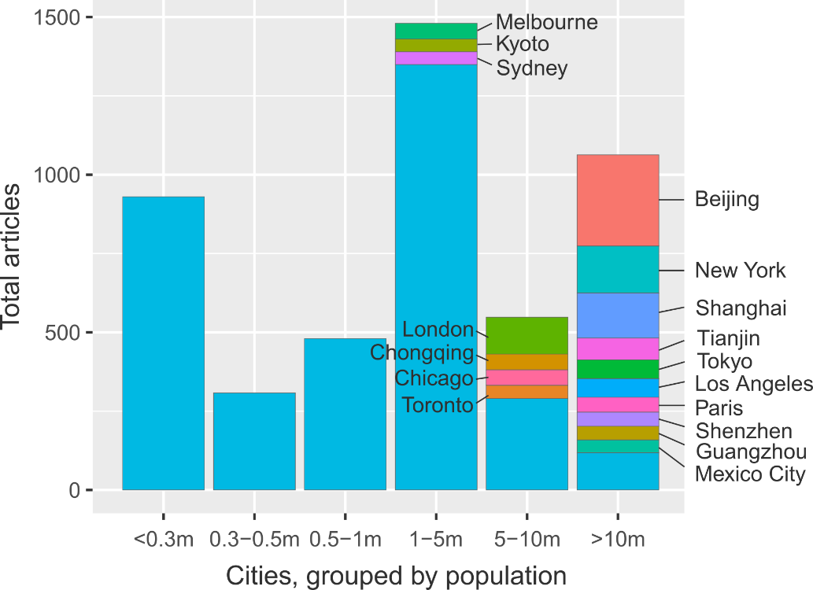

Figure 1: Summed urban climate mitigation articles, grouped according to city size. Where available, urban agglomeration data is used. Cities with more than 40 articles are identified.

Considering the global population distribution across these different city types, is the current focus of research justified? Figure 2 shows, by region, the proportion of articles, article citations and inhabitants for each size of city. Worldwide, we observe a bias towards research on larger cities over smaller cities. These results are most stark in Asia, where articles on mega-cities account for almost x% of all studies and gather x% of citations, relative to smaller cities. In stark contrast to the predominant focus of research, Asia has a very low proportion of mega-city inhabitants (10%), and a high proportion of inhabitants living in small agglomerations of less than 0.3m persons (33%). Similar mismatches can be seen in Europe, Latin America, North America and Oceania. Moreover, citations patterns can exacerbate the literature bias – exaggerating the influence of studies on large cities and downplaying the importance of small cities, even where the literature is available (for instance in Europe, where x% of articles refer to small cities, but receive only x% of citations in the region).

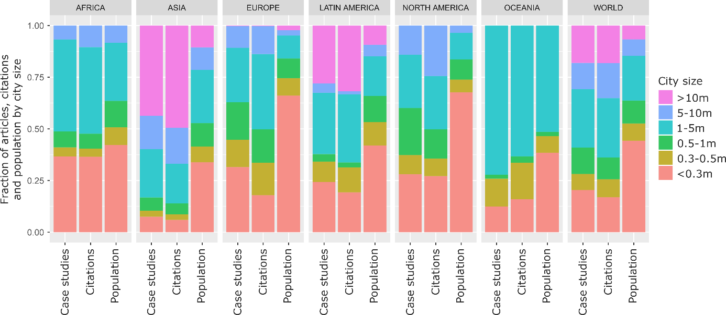

Figure 2: Regional size and citation biases in urban mitigation case study research

Regionally, there is a clear bias towards Europe and North America, which receive an outsized share of articles and an even greater share of citations relative to their small proportion of the global urban population (SI Text Fig 1). The opposite trends prevail in Asia, Latin America and Africa, which are systematically under-studied and under-citied in the literature.

In sum we demonstrate some clear biases in the urban case study research: larger cities in Europe and North America tend to be favoured in analysis, as well as a small number of specific mega-cities. Citations follow suit and even exacerbate inter-city and inter-regional differences. Our sample of studies captures some non-English language articles (180 in total), but certainly not all; nor does it capture grey literature such as NGO reports. Nonetheless, the results clearly reflect a global division of scientific labour and resonate with wider struggles to situate developing country authors and research in the IPCC assessments.

Urban growth in the 21st century will take place in small and medium-sized cities in Asia and Africa (SI Text Fig 1; UN projections) – precisely the cities on which we lack research. Locating research efforts, stakeholder engagement and policy advocacy in these regions will be instrumental to avoiding lock-in and realising compact, low-carbon urban forms that can tackle the coming mitigation challenge 12,13.

**What topics do we know about?**

As the literature expands it becomes progressively more difficult to grasp the overall topic space of a scientific field. This is particularly the case for the urban studies, where a diverse array of topics are divided among various epistemic communities 1. We therefore turn to natural language processing methods to outline the scope of mitigation research being carried out on cities. Using the identified case studies we construct a matrix of documents and the words they contain (abstracts only), factorising to obtain the ‘topics’ that describe commonly co-occurring words across the document set (see methods). In essence, machine reading software discovers the latent themes that permeate the document set and categorises each document accordingly, substituting for the laborious task of reading and tagging each article by hand.

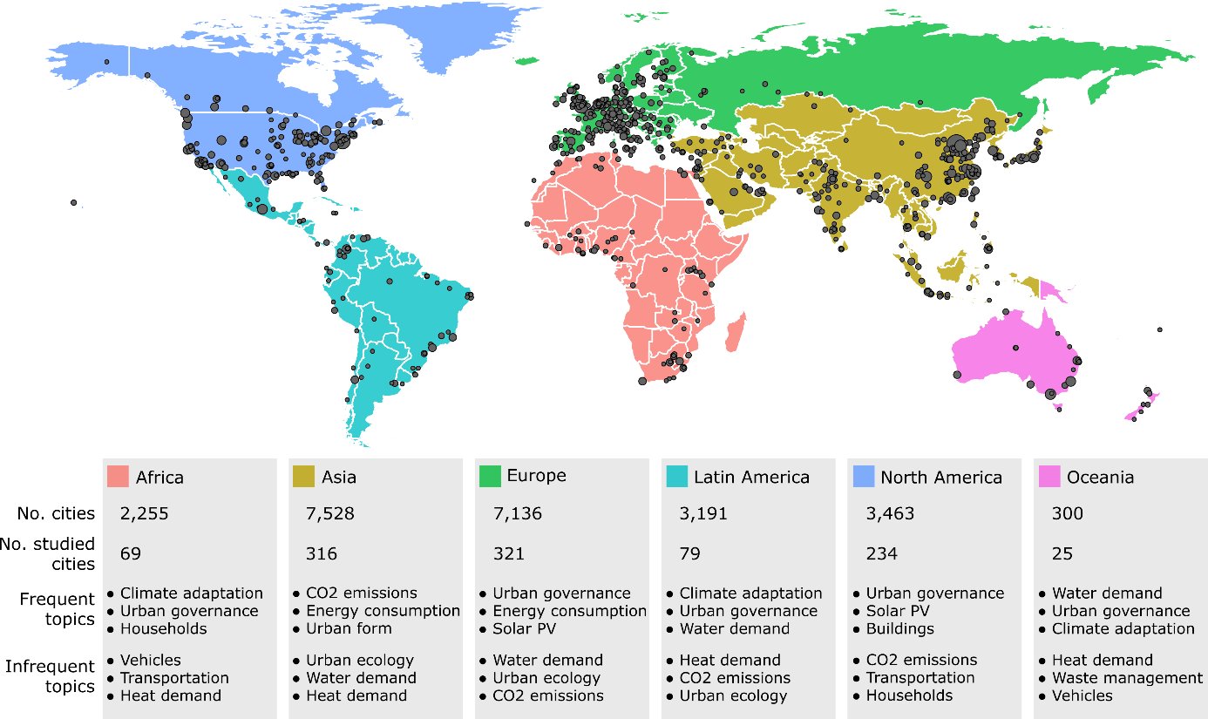

Figure 3: Urban case study cities and topics by region

We isolate 17 broad topic areas in the set of case studies (SI Text Table 1). As might be expected this includes topics on urban governance, urban form, energy consumption, and CO2 emissions accounting in cities. A tendency towards demand-side climate mitigation topics can be observed, including transportation, waste management and end-use energy and heat demand in buildings and households. A single supply-side topic is present: on solar PV. The presence of topics on air pollution, water demand, urban ecology and climate adaptation highlights the integration of climate mitigation with wider sustainability issues in cities.

Overall this topic space is well aligned to discussions in the literature, situating the urban context as the site of everyday energy use via behaviours, practices and infrastructure provisioning – and hence the locus of demand-side mitigation measures 14 (REF). It also confirms that the urban literature, and case studies more specifically, are directly addressing clusters of issues at the heart of the 2030 Agenda for Sustainable Development, e.g. on vehicles, mobility and human health (REF); or urban governance practices for mitigation and adaptation (REF).

Regional divisions in topics might be expected from the literature. Figure 3 lists the frequently and infrequently occurring topics by region, bearing this out. For instance, the topic of urban governance, which captures policies and policy-making, is prevalent in all regions with the exception of Asia, where studies focus instead on CO2 emissions accounting and structural issues of urban form. We also observe regional variations in adaptation focus (Africa, Latin America and Oceania), supply-side studies (Europe, North America), …

[Paragraph on scenario words].

**Which cities are reviewed and compared?**

What studies use systematic methods?

What studies aggregate case studies, without systematic methods?

What type of comparative work takes place between cities and regions?

**Towards learning about urban mitigation solutions**

Although the sample of urban mitigation documents we analyse is by no means comprehensive, it is suggestive of important deficiencies within the literature. Articles on cities in Africa and parts of Asia are sparse, and the literature has yet to anticipate and respond to urbanisation issues arising in these regions. An increased focus along these lines is called for – as is the integration of knowledge from fields that do not yet directly address mitigation concerns, such as fuel poverty, or much of the literature on mobility and congestion.

Reviews are no substitute for primary studies, but are critical to learning from the literature as a whole – especially as it rapidly grows. Reviews of the case study evidence are difficult however, as they must grapple with a diversity of study designs, locations and scales.

3 conditions for case study reviews:

- transparent selection of literature, methods used here can help.

- structured review approaches. Aim to uncover what works, for whom, under what circumstances. Appropriate methods are: meta-survey (coding/analysis of qualitative info), meta-analysis (where quantitative data), realist reviews.

- Logics of generalisability:

- Global impact (large or geopolitically influential city).

- System relevance (city shares similar traits with other cities). Plenty of work on typologies.

- Problem relevance (ubiquitous issues with common characteristics across all types of systems -> urban sprawl = congestion)

- Suggests 4 types of reviews that would be helpful for assessments:

|  |  |  |
| --- | --- | --- |
|  | Single issue | Multiple issues |
| Single city | Implementation narrative and robust evaluation of outcome.  e.g. Pathway to climate policy in New York City (**logic: global impact, problem relevance**) | Assessment of problem interlinkages  e.g. ‘Proof of concept’ that sustainable urbanisation can address health and emissions (Medellin?) (**logic: problem relevance**) |
| Multiple cities | Assessment of contextual drivers of outcome variation |  |

1. Lamb, W. F., Callaghan, M. W., Creutzig, F., Khosla, R. & Minx, J. C. The literature landscape on 1.5°C Climate Change and Cities. *Curr. Opin. Environ. Sustain.* **30,** 26–34 (2018).

2. Scott, A. J. & Storper, M. The nature of cities: The scope and limits of urban theory. *Int. J. Urban Reg. Res.* **39,** 1–15 (2015).

3. Creutzig, F., Baiocchi, G., Bierkandt, R., Pichler, P.-P. & Seto, K. C. Global typology of urban energy use and potentials for an urbanization mitigation wedge. *Proc. Natl. Acad. Sci.* (2015). doi:10.1073/pnas.1315545112

4. Sudmant, A., Gouldson, A., Millward-Hopkins, J., Scott, K. & Barrett, J. Producer cities and consumer cities: Using production- and consumption-based carbon accounts to guide climate action in China, the UK, and the US. *J. Clean. Prod.* **176,** 654–662 (2017).

5. Global Covenant of Mayors. Global Covenant of Mayors for Climate & Energy. (2017). Available at: http://www.globalcovenantofmayors.org. (Accessed: 10th November 2017)

6. Grandin, J., Haarstad, H., Kjærås, K. & Bouzarovski, S. The politics of rapid urban transformation. *Curr. Opin. Environ. Sustain.* **31,** 16–22 (2018).

7. Bulkeley, H. & Castán Broto, V. Government by experiment? Global cities and the governing of climate change. *Trans. Inst. Br. Geogr.* **38,** 361–375 (2013).

8. Minx, J. C., Callaghan, M., Lamb, W. F., Garard, J. & Edenhofer, O. Learning about climate change solutions in the IPCC and beyond. *Environ. Sci. Policy* **77,** (2017).

9. Solecki, W. *et al.* City transformations in a 1.5°C warmer world. *Nat. Clim. Chang.* **8,** 175–185 (2018).

10. Bai, X. Industrial Ecology and the Global Impacts of Cities. *J. Ind. Ecol.* **11,** 1–6 (2007).

11. Steinberg, P. F. Can We Generalize from Case Studies? *Glob. Environ. Polit.* **15,** 152–175 (2015).

12. Karen C., S. *et al.* in *Climate Change 2014: Mitigation of Climate Change. Contribution of Working Group III to the Fifth Assessment Report of the Intergovernmental Panel on Climate Change* 923–1000 (Cambridge University Press, 2014). doi:10.1017/CBO9781107415416.018

13. Creutzig, F. *et al.* Urban infrastructure choices structure climate solutions. *Nat. Clim. Chang.* **6,** 1054 (2016).

14. Creutzig, F. *et al.* Beyond Technology: Demand-Side Solutions for Climate Change Mitigation. *Annu. Rev. Environ. Resour.* **41,** 173–198 (2016).

15. Robinson, J. Cities in a World of Cities: The Comparative Gesture. *Int. J. Urban Reg. Res.* **35,** 1–23 (2011).

16. Castán Broto, V. & Bulkeley, H. A survey of urban climate change experiments in 100 cities. *Glob. Environ. Chang.* **23,** 92–102 (2013).

17. Reckien, D. *et al.* Climate change response in Europe: What’s the reality? Analysis of adaptation and mitigation plans from 200 urban areas in 11 countries. *Clim. Change* **122,** 331–340 (2014).

18. Heidrich, O., Dawson, R. J., Reckien, D. & Walsh, C. L. Assessment of the climate preparedness of 30 urban areas in the UK. *Clim. Change* **120,** 771–784 (2013).

Old text

– for instance about the political economic barriers to transitions. In addition, there are claimed biases in the body of case study literature , including the tendency to focus on large, wealthy cities in the global North, at the expense of rapidly urbanising areas in Asia and Africa 2,15,16.

Although there have been some efforts so far to aggregate knowledge from urban studies and climate action plans16–18, AR6 will be an important opportunity to systematically learn about urban mitigation solutions.

**Supplementary information**

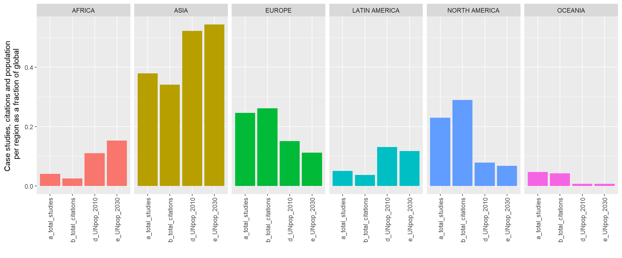

Fig 1: Regional biases in urban case study research and citations

|  |  |  |  |
| --- | --- | --- | --- |
| **ID** | **Topic Name** | **Stemmed Keywords** | **Marginal Topic Distribution** |
| 1 | Urban governance | citi; polici; govern; local; develop | 9.3 |
| 2 | Energy consumption | energi; consumpt; effici; sector; beij | 7.9 |
| 3 | Urban form | urban; area; land; ecolog; model | 7.2 |
| 4 | Solar PV | system; solar; power; electr; energi | 7.0 |
| 5 | CO2 emissions | carbon; emiss; industri; china; lowcarbon | 6.8 |
| 6 | Buildings | build; design; energi; perform; residenti | 6.8 |
| 7 | Climate adaptation | climat; chang; adapt; risk; govern | 6.5 |
| 8 | Air pollution | air; pollut; health; qualiti; concentr | 6.2 |
| 9 | Transportation | transport; travel; traffic; public; car | 5.7 |
| 10 | GHG emissions | ghg; emiss; greenhous; gas; reduct | 5.4 |
| 11 | Vehicles | vehicl; electr; fuel; drive; emiss | 4.8 |
| 12 | Households | household; incom; electr; survey; hous | 4.7 |
| 13 | Waste management | wast; landfil; solid; manag; msw | 4.6 |
| 14 | Water demand | water; suppli; manag; demand; treatment | 4.6 |
| 15 | Heat demand | heat; district; thermal; demand; network | 4.6 |
| 16 | Green roofs | roof; temperatur; cool; green; surfac | 4.5 |
| 17 | Urban ecology | tree; forest; plant; speci; sequestr | 3.4 |

Table 1: List of topics and their keywords

Table of review studies

Table of comparative studies

Figure of regional comparisons